

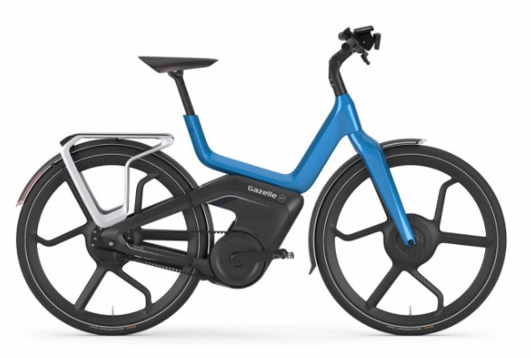

tABLE OF contents

Design history 3

Game concept 4

Target Audience (clients point of view) 4

target platform 4

Platform 4

Minimal device 4

Recommended device 4

Game Flow Summary 5

Gameplay 6

Mechanics 7

Interactive Objects 7

Behaviors 7

Object relationships 8

Story and Game progression 9

Story and background 9

Game progression 9

Levels 9

Interface 10

Cost 11

Project rules 13

Folder structure 13

File types 13

Technical choices 14

Rendering and view 14

Physics 14

Scene management 14

AI 14

Manager objects 14

Interface 15

Players 15

Data storage 15

Cutscenes 15

# Design history

|  |  |  |
| --- | --- | --- |
| Date |  | Changes |
| 16-04-18 |  | Initial design |
| 17-04-18 |  | Added target audience (clients view), game concept & gameplay |
|  |  |  |
|  |  |  |
|  |  |  |
|  |  |  |
|  |  |  |

# Game concept

You’ll create your own bike in the customization screen, with it’s own engine, color etc. And then you’ll race against each other and use items to stop each other. It’s tournament style, so the 1st and 2nd place will move forward in the competition and in the last round the winner wins the bike that they created.

# Target Audience (clients point of view)

Gazelle want to advertise their bikes to 18 – 70 year olds. They’ve chosen 18+ because they sell e-bikes and you need to be older than 18 to ride those bikes. And also a very big range of older ages because they want to sell their product to as many people as possible

# target platform

## Platform

We are making this project to be able to run on desktop (Windows/Linux/Mac)

## Minimal device

OS: Windows Vista SP1+, Mac OS X 10.9+, Ubuntu 12.04+, SteamOS+.

Graphics card with DX10 (shader model 4.0) capabilities.

CPU: SSE2 instruction set support.

## Recommended device

A modern day pc/laptop with internet access.

# Game Flow Summary

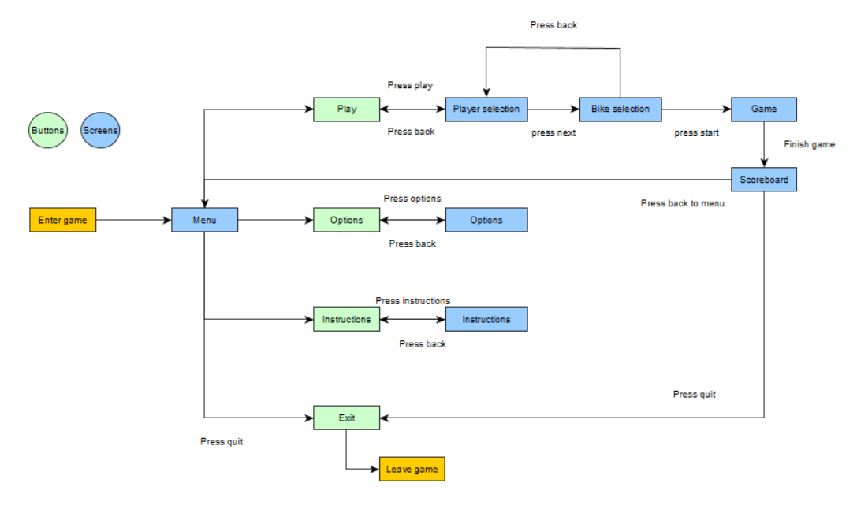

# Gameplay

By using your mouse/controller you can select and press the buttons that will control the screens.

You can customize your character/bike after you press play. This by selecting from a range of options and selecting them on the screen. [shows additional information (of the bike specifications) when hovered over]

You can pick up item blocks that will have a range of useful items to slow down players.

These are the options of items in the game:

* Oil [ leaves a trail of oil behind you that slows players ]
* (green) Energy boost [ gives a speed boost to you ]
* (small toy) Car [ follows the road from your position to the first player and hits them and explodes, stuns enemies on the way when it hits them]
* Bell [ stuns nearby players for a short period of time ]

You can also go over speed pads which give you an additional speed boost for a short period of time.

You win by ending up in first place at the end of the race and lose if you don’t.

At the end of the game you get to see your position and the time you finished it in and choose to return to the menu and replay against new it or exit the game.

# Mechanics

## Interactive Objects

|  |  |  |  |  |
| --- | --- | --- | --- | --- |
| **Object** |  | **Does** |  | **How** |
| Play Button |  | Plays the game |  | By clicking it with your mouse/controller |
| Options Button |  | Opens the option menu |  | By clicking it with your mouse/controller |
| Donation Button |  | Opens the donation menu |  | By clicking it with your mouse/controller |
| Exit Button |  | Exits the game |  | By clicking it with your mouse/controller |
| Back Button |  | Goes back to the menu |  | By clicking it with your mouse/controller |
| UI |  | Keeps track of position & time |  | Gets position from player |
| Scoreboard |  | Gets winner |  | Gets end positions from UI |
| Bike/Player customization |  | Updates the player/bike |  | By selecting different options your player/bike will change |

## Behaviors

|  |  |  |  |  |  |
| --- | --- | --- | --- | --- | --- |
| **Type** |  | **Description** |  | **How does it do it?** | **Expectable situations** |
| Button |  | When clicked something happens |  | When you click with your mouse something happens (what the name of the button says) | Plays the game, opens the option menu, opens the rules menu, exits the game, goes back to the previous screen, opens the pause menu |
| Scoreboard |  | Checks the time on each level for every player and the 1st and 2nd place will automatically progress to the next round |  | If you open op the score menu it will show how high you are on the leaderboard and what players will progess |  |
| Player |  | Everything the player can do will be done here |  | It takes the input from the player, and uses it. |  |

## Object relationships

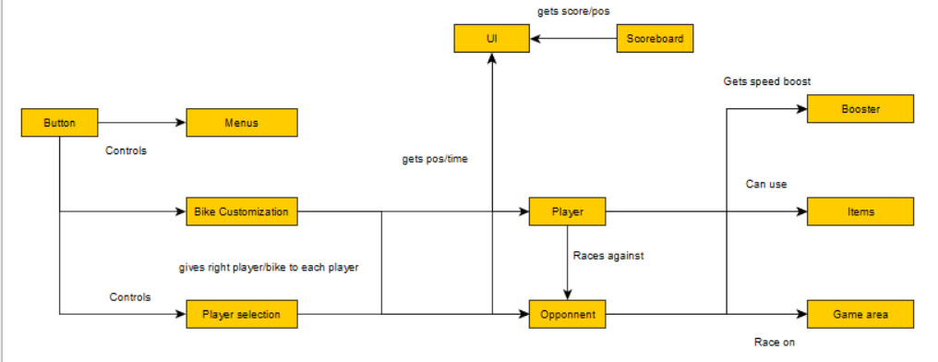

# Story and Game progression

## Story and background

You are pretty good with riding a bike and you want to show of your skills, lucky for you there’s a competition in town where the big price is a brand new customized bike. Since that bike will defiantly be better than the one you got right now you decide to enter the competition to win the grand prize.

## Game progression

You can select your own levels to play, and based on other peoples votes you’ll get a chosen map. If you participate in the tournament you’ll start of with easy maps with not a lot of obstacles and lots of items. If you progress in the tournament the levels will be more challenging and items will be more and more rare.

# Levels

We’ll start of with a option of 4 levels that the player can pick from, from 1 – 4 the levels difficulty is slightly increased due to there being more obstacles to dodge and less items.

1. Beach
   * Water to slow you down, some palm trees
2. City
   * Garbage bins, ramps and shortcuts
3. Mountain
   * Rough corners, falling stones and tricky ramps
4. Jungle
   * Lots of trees, small rivers and bumpy roads

# Interface

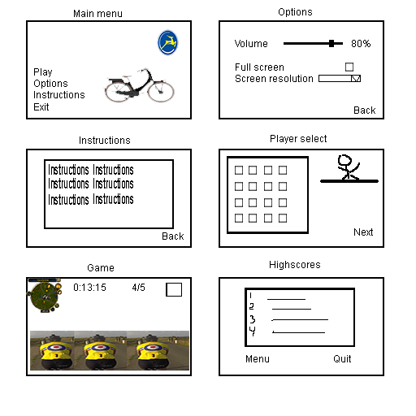

# Cost

|  |  |  |  |  |  |  |  |  |
| --- | --- | --- | --- | --- | --- | --- | --- | --- |
| **Roles needed** |  | **Why?** |  | **How long needed** |  | **Cost per hour** |  | **Total cost** |
| Audio design |  | Every good game has music in it |  | 1 week |  | €45-, an hour |  | €1.800-, |
| *Art* (2) |  | We need to make it look pretty |  | 3 months |  | €40-, an hour |  | €7.680-, |
| *Development* (2) |  | We need someone to make the game |  | 3 months |  | €50-, an hour |  | €9.600-, |
| Play tester |  | We need some feedback from outside to make sure it’s fun to play |  | 3 days |  | €30-, an hour |  | €720-, |
| Project manager |  | We need someone to make plans and make sure everything goes as plan |  | 3 months |  | €60-, an hour |  | €5.760 |
|  |  |  |  |  |  |  |  | **Total : €25.561** |

People working on the project will mostly work 8 hours a day 5 days a week, we begin work at 8:30 am till 5:00 pm with half an hour break at 12:30. (breaks will not be charged)

|  |  |  |  |  |
| --- | --- | --- | --- | --- |
| **Accommodation** |  | **Usage** |  | **Cost** |
| Unity pro |  | This is where we will make the game in |  | €125 /month  €1.500 / year |
| Maya 2018 (optional) |  | We will make the models in here |  | €242 / month  €1.936 / year |
| Photoshop |  | We will make the design and textures in here |  | €24,19 / month  €290,17 / year |
|  |  |  |  |  |
|  |  |  |  | **Total: €319,19 / month**  **€ 3.726,17/ year** |

Since we’ll only work on this for 3 months the cost would be **€957,57**

Not including Maya 2018 will make it drop down to **€591,71**

Team cost ( 2 artists & 2 Developers ) **€17.280**

All the cost together ( Team costs & with Maya ) would be a total of **€18.237,57**

All the cost together ( Team costs & without Maya ) would be a total of **€17.871,71**

# Project rules

## Folder structure

|  |  |  |
| --- | --- | --- |
| **Folder** |  | **What goes in** |
| Scripts |  | All scripts that are being made, and used go in here. Also in a sub folder with the usage |
| Assets |  | All art that comes in go in here, in a sub folder for location and usage |
| Textures |  | All textures go in here, in a sub folder for the object |
| Prefabs |  | All prefabs go in here |
| Animations |  | All animations go here, with a sub folder of usage |
| Music |  | All music go in here, with a subfolder for sounds ( like jumping ) and a folder for the type of music |
| Levels |  | Every level is in their own sub folder |

## File types

|  |  |  |
| --- | --- | --- |
| **File types** |  | **Purpose** |
| .wav |  | Sound/music |
| .fbx |  | So textures are already on it |
| .cs |  | All classes |
| .psd/png |  | .psd is for textures, .png is for alphas |

# Technical choices

## Rendering and view

Forward rendering path, because it’s the cheapest to use.

Gamma color space because it makes the game look pretty.

The game will have a 3D third person view so you can view ahead, and also a little behind you.

## Physics

it’s a 3D game, with no ragdolls, the game will have physics made in code based on every bike option.

## Scene management

We’ll have 2 scenes, the menu and the game. The load screen will be stacked on the game scene so it will load in the background.

## AI

We’ll use a behavior tree to check every possibility that the AI can make, and choose an appropriate option.

## Manager objects

We use managers, like an Audio manager that takes care of the audio.

|  |  |  |
| --- | --- | --- |
| **Manager** |  | **Responsibility** |
| Audio |  | Plays every sound/music |
| Level |  | Keeps track of the objects in the game |
| Score |  | Keeps track of the score in the game |

Everything that’s not in this list will be a scriptable object.

## Interface

We’ll use the basic Unity UI to make our GUI.

Everything can be clicked on it and the name interprets what it does. ( play goes to play mode, options opens an options screen etc. )

## Players

The game is on desktop and is online multiplayer.

The player can play and interact with everything on screen with their mouse/keyboard.

You are able to remap your controls, for controller and keyboard so everyone can play their own game their way.

## Data storage

All score will be saved into a small database time and the top players will move forward on the leader board.

It is a online scoreboard because you’re competing against other players.

## Cutscenes

There will be no cutscenes in the game.